Numerical Differentiation
From the Taylor expansion
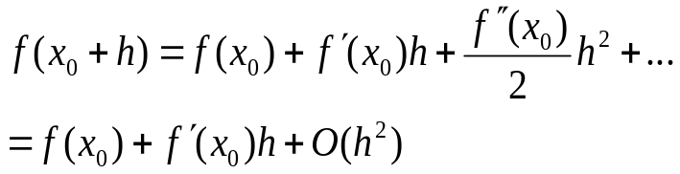
We get
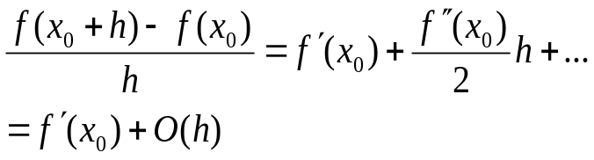
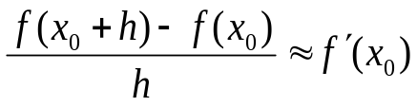 Forward difference formula
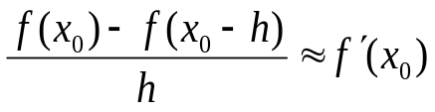 Backward difference formula
Three point formula:
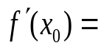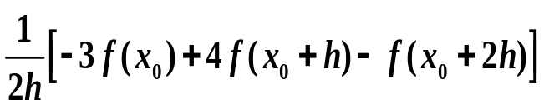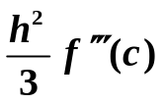
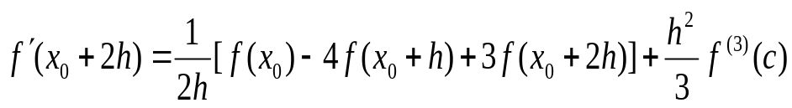

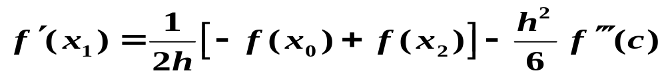
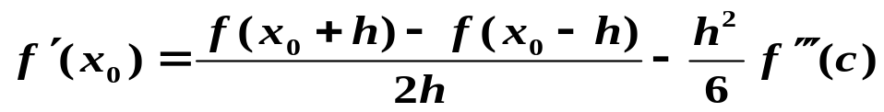
- central-difference formula

